Tinnitus Clinic

Specialists in Evidence-Based Tinnitus Recovery

​

**8333 1010**

​

Talk to experts who understand the whole auditory pathway from ear to brain.

12-week Tinnitus Recovery Program

**Experience - Innovation - Results**

The Tinnitus Clinic provides professional evidence-based clinical services that draws from current research understanding of the neuroscience behind tinnitus and which aim to influence brain states in the treatment of tinnitus.

We have developed a unique trimodal evidence-based treatment model which utilises a combination of tinnitus counselling, neurofeedback and hypnosis to therapeutically influence brain plasticity and cognitions which have shown to reduce the perception of tinnitus.

Our clinical protocols are guided by those principles outlined by the Tinnitus Research Initiative (TRI). Tools for assessment and evaluation are based on established international questionnaires for tinnitus research.

Our services are provided within a sound and ethical context based on professional and evidence-driven protocols for the treatment of tinnitus.

**SECURE YOUR WEEKLY TREATMENT SLOT NOW**

8333 1010

**Unique Tri-Modal Treatment Approach**

**Program Outline**

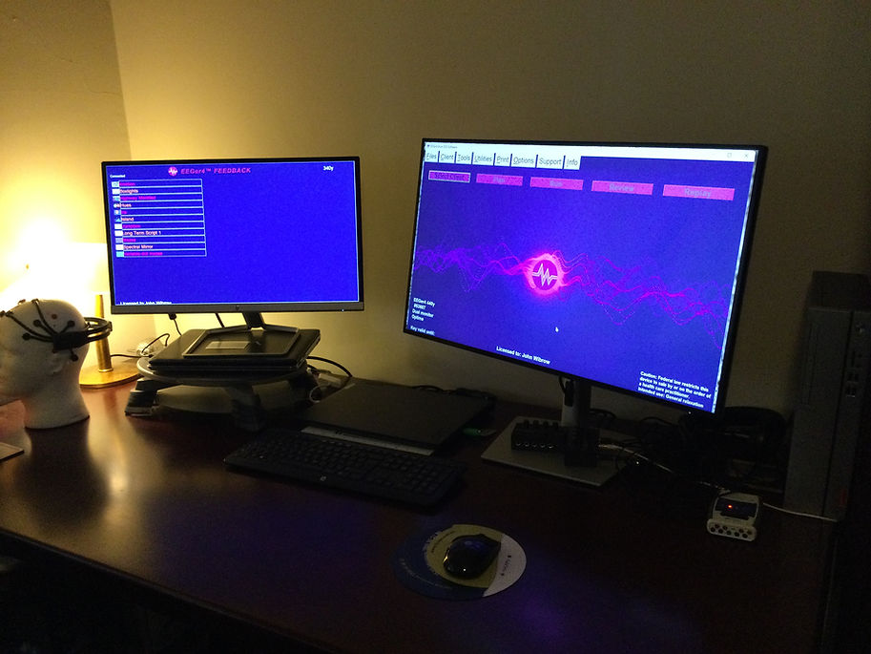

**Client Testimonials**

**Professional Team**

